SCIENCE INTERACTIVE
NOTEBOOK

“
Your Key To Success in Science
”

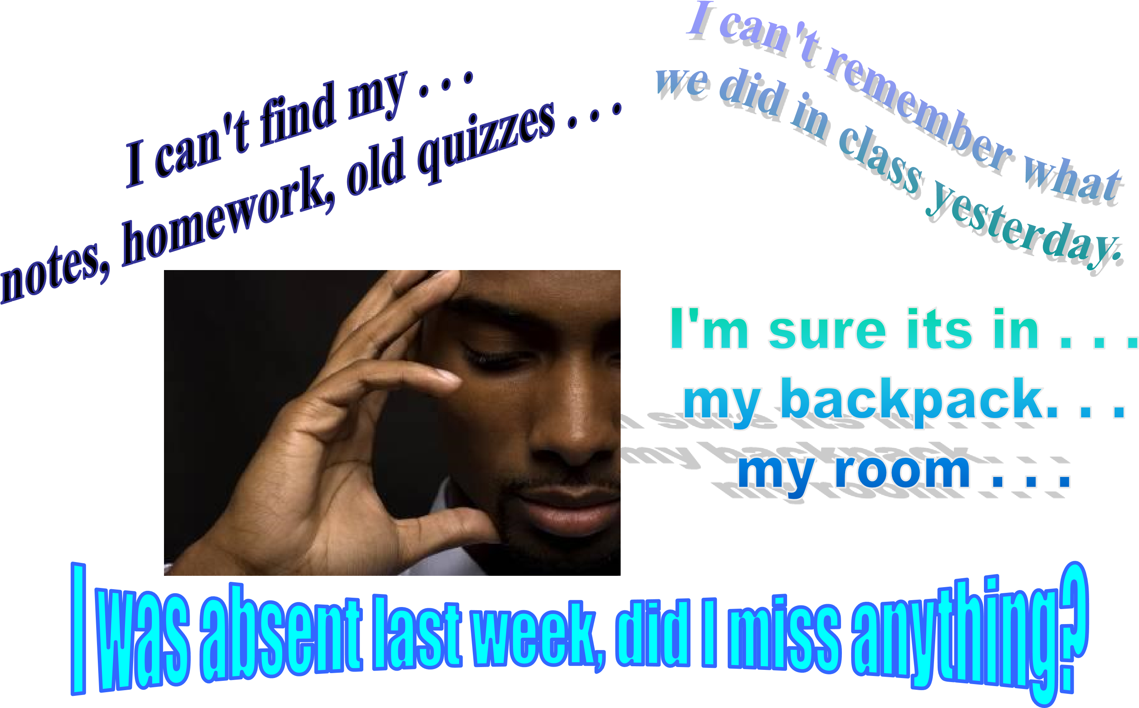

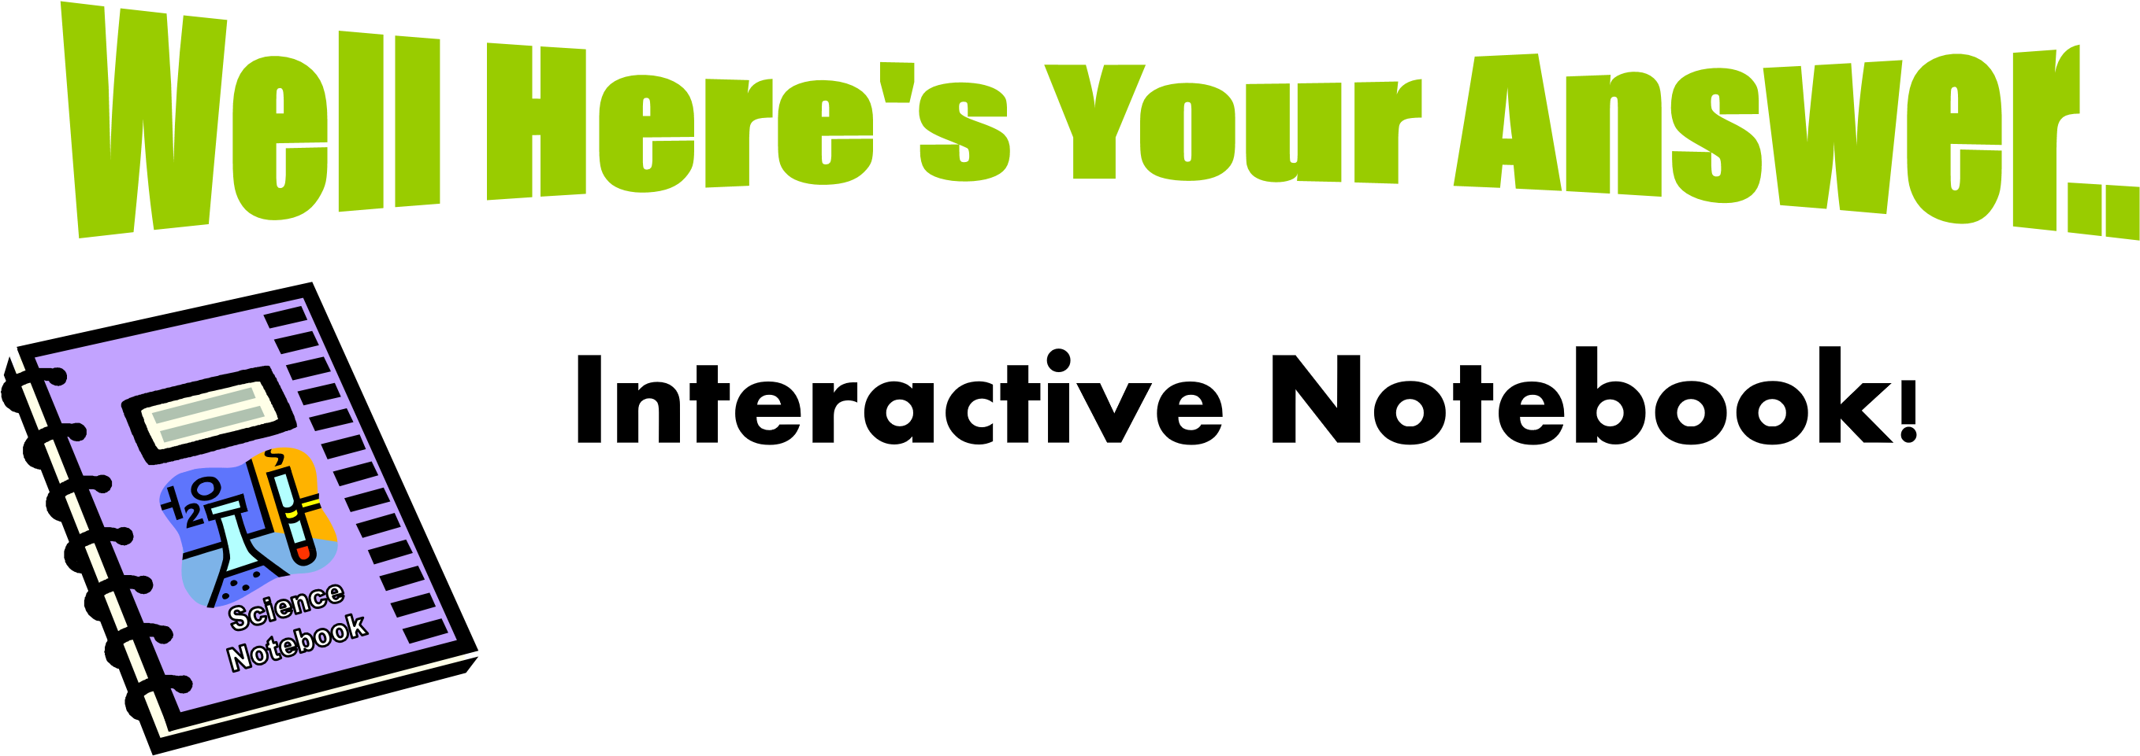
Even though we may not think it, scientists are very organized. One tool they use to keep organized is a notebook. Their notebooks contain their closely their closely guarded secret findings, and sometimes patented solutions to problems.

YOU are a scientist! Believe it or not! So you will be required to maintain a science class. Everything you receive in my class will become part of your notebook.

Now you will have a prized possession just like other scientists!

- A interactive notebook (INB) your own personalized DIARY of learning about science
- A portfolio of your work in ONE convenient spot. This is great for studying for upcoming quizzes &
tests
- A great ORGANIZATIONAL tool that gives you permission to be PLAYFUL AND CREATIVE in your responses without "messing up" your notes.
- Allows you to be like a REAL SCIENTIST!

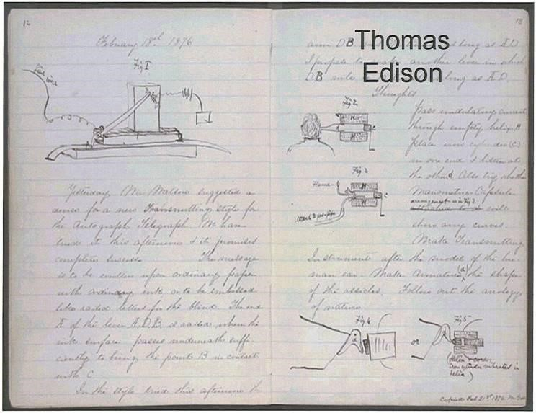

What will my notebook look like?

•
All the pages will be numbered

•

•Every page will have a date and each day you will enter items into your table of contents.

•EVERYTHING will be in your science notebook!

Let’s check out some Notebook Rules…

- Do not RIP OUT pages or tear corners • All handouts MUST BE GLUED/TAPED IN!
- Please don’t DOODLE unless it relates to science • Your INB should only be used for SCIENCE
CLASS and COMES TO CLASS EVERYDAY

• Each page should have the DATE, PAGE# and TITLE • Write ALL entries in the Table of Contents • BE COLORFUL & LOVE YOUR NOTEBOOK

For the front of your INB…
- The name of the course:

- Your teacher: Mrs. Diaz
- Your name: (self explanatory)
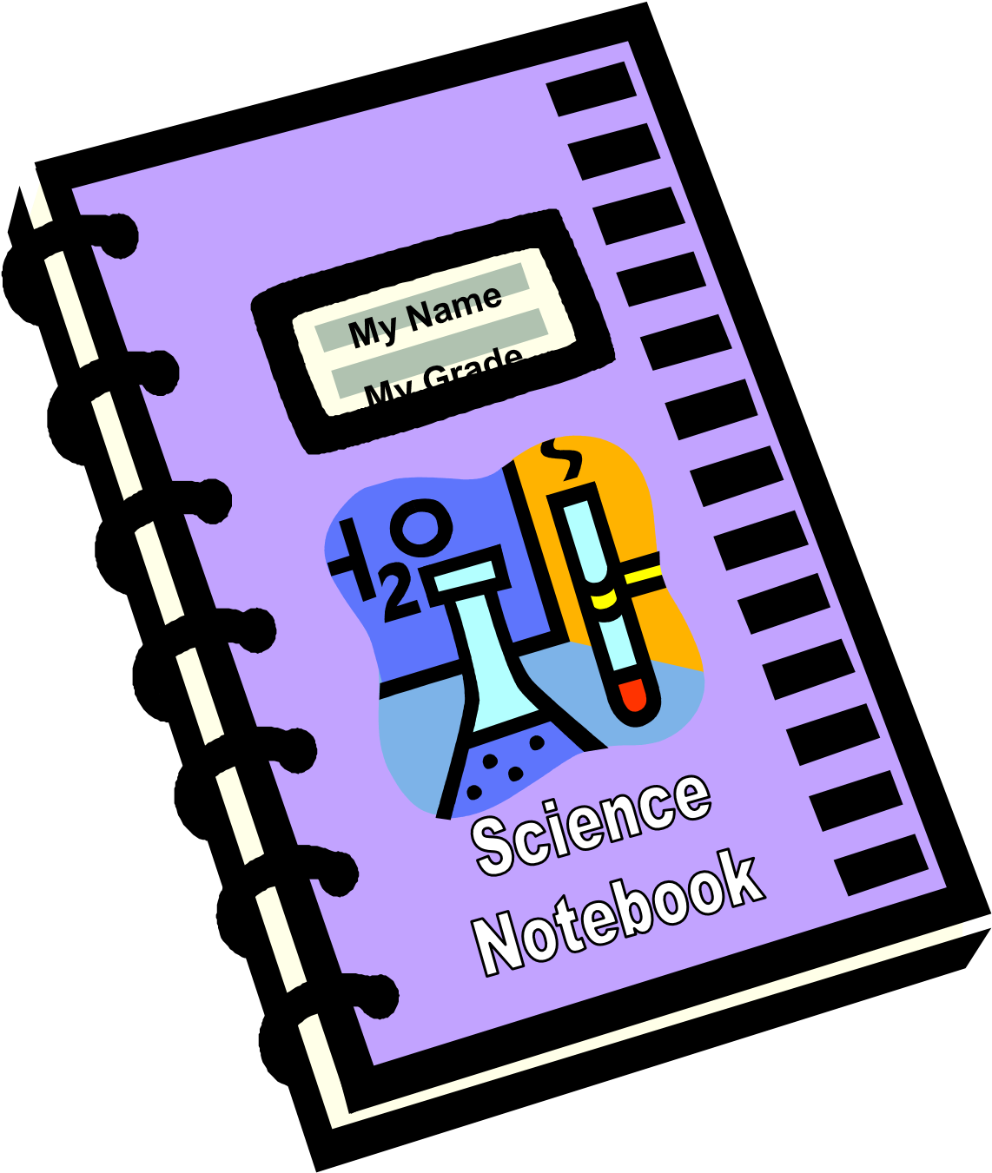
- You may want to put science pictures on the front/back of your notebook.

- Now you will number the first 50 pages.
- The 1st page is 1 – EVEN numbers will always be on the RIGHT and ODD numbers on the LEFT. Number at the TOP OUTSIDE CORNER of every page.
2

AUTHORS
PAGE

“
ALL ABOUT
YOU PAGE
”

1

Inside front cover

Guidelines

Page 1

The other
side of the
“
Authors
Page
”

- Label the following pages on the top line with their title listed on their prospective page number:

2-5
Table of
Contents

The last four pages of your INB will be your INDEX. The index will be divided up into alphabetical order.

Let’s turn to the doc camera for the example

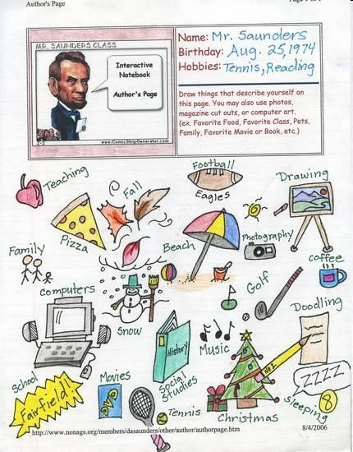

Sample

Author

P a g e

- Complete your AUTHOR’S PAGE and the COVER of your INB
- Both are DUE by class the next class,
- You can do these on a separate piece of paper and paste them into/onto your notebook.
- Have Fun!

DATE | DESCRIPTION | PAGE #
The notebook is divided into TWO sections.

- The Left side “LEARNS”. This is the side contains only information given by the teacher. Nothing else should be placed on the LEFT SIDE!!

- The Right side “REFLECTS”. This is the side that you write conclusions, analyze experiments and reflect on lessons, experiments or tests.

- The RIGHT SIDE belongs to the teacher, and therefore should only contain information given or “input” from me.
- This is the ESSENTIAL information that will DEFINITELY be on a quiz or test. Nothing else should go on this side.
ODD PAGES =1, 3, 5, 7, 9…YOU GOT IT..
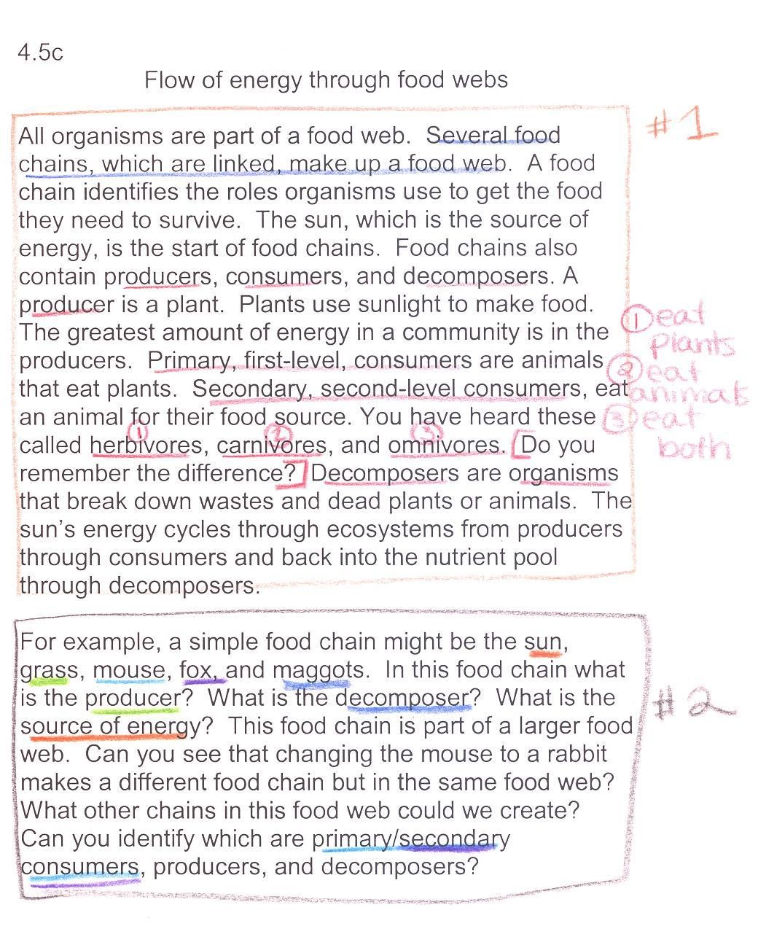
•
Notes from

–
Powerpoints

–
Movie/Video

–
Article Readings

•
Scientific vocabulary
exercises

•
All labs

•
Study Guides

- The RIGHT SIDE belongs to you. Every right side page gets used!

- Output exercises: summaries, thinking maps, tables, graphs, word webs, concept maps, diagrams, Venn diagrams, pictures/drawings, brainstorming, poems, raps, quotes, songs, cartoons, weird and bizarre thoughts and ideas and reflections.
Even Pages = 2,4,6,8..YOU KNOW IT.
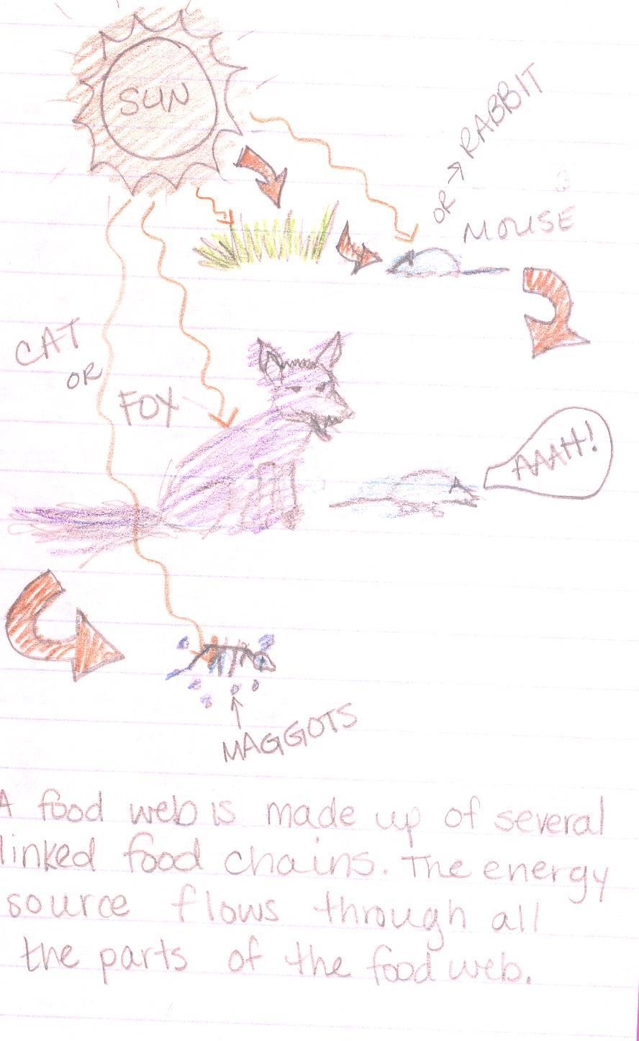
The
warm
-
ups
are

also
placed on the
LEFT
side of
the notebook.
You will get a
blank piece of notebook
paper, do the warm
-
up and
tape it in your book on the
left side. Warm
-
ups act
as a
reinforcement of the
lesson.

Remember, warm
-
ups are done in the First 5!

Fill in the missing word.

Left Right Notebook Paper

Handouts from the teacher go on the ___ side. I get to be creative, analyze and show what I learned
on the ___ side. My warm-ups will be done on ______side of my notebook.

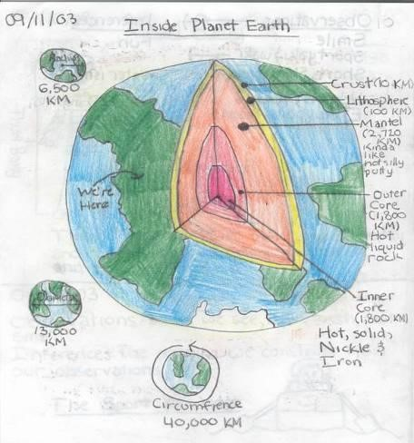
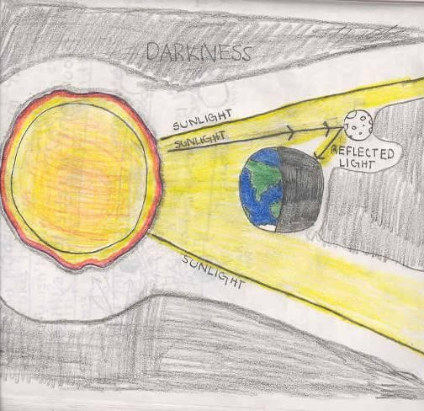
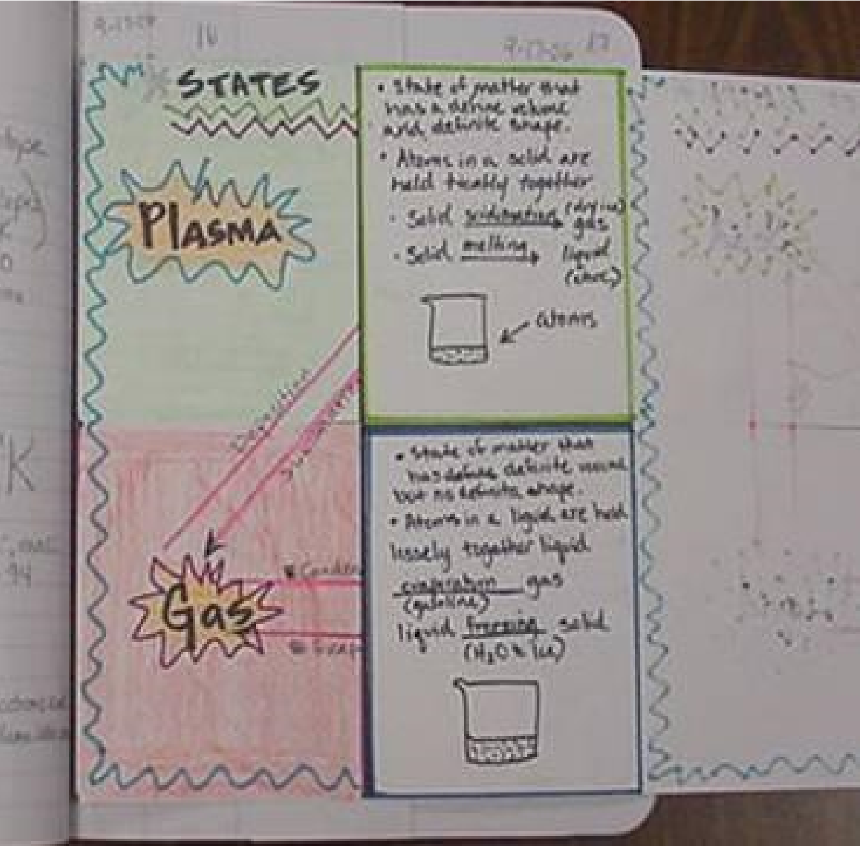
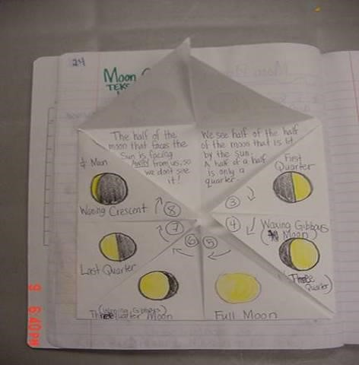
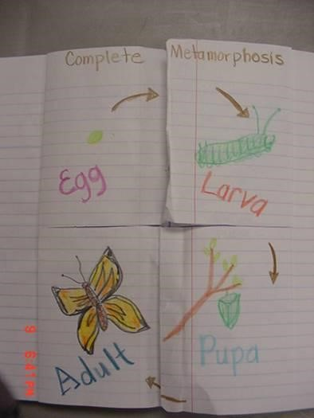
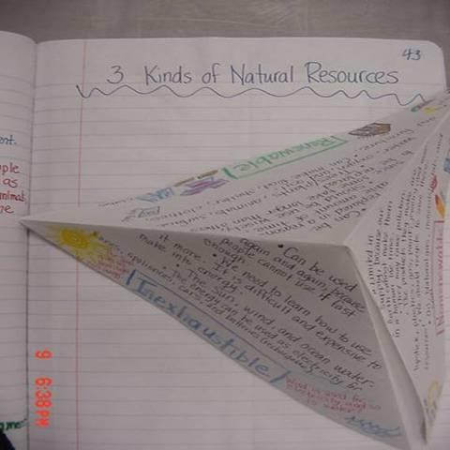
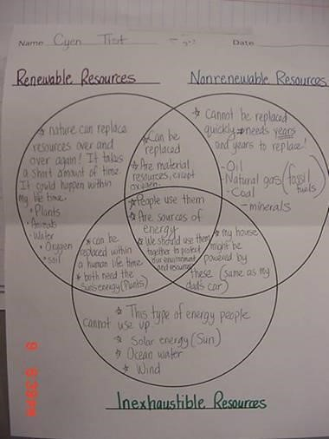
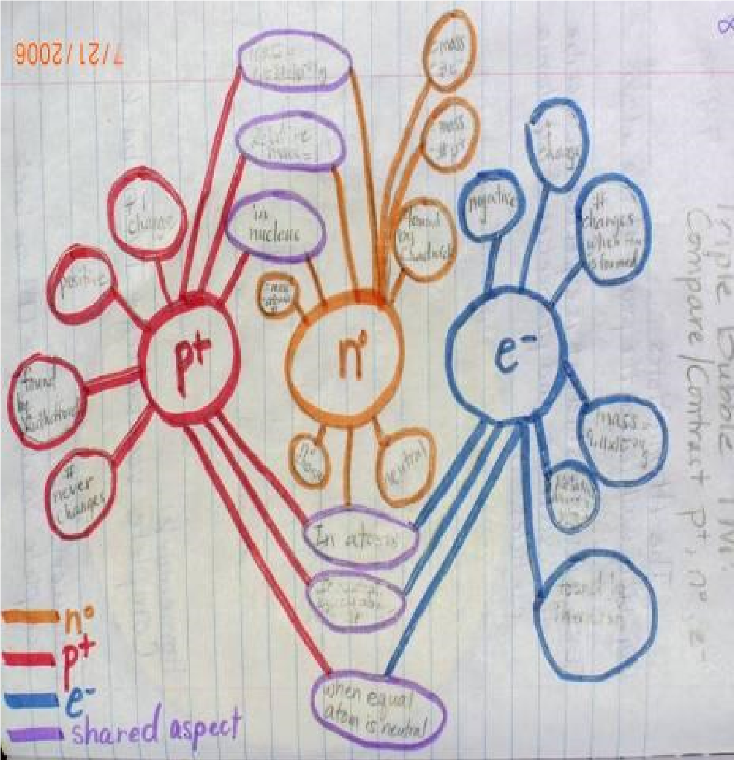

- “INB's are easy to do and • worth a lot of points, so take time and effort to do them well.“
- "Always update your table of contents so papers don't • get messed up - or in case of
an INB check.“ •
- "An INB is a great tool, keep it organized!“
- "You have to spend quality • time on your INB.“
"Don't leave your INB until the last day, otherwise you may be up to the early morning hours finishing assignments.“ "Colorize things. It looks so much better that way” "Keep it in order, because you never know when a notebook check might come up.“ "Do not save your INB until the last minute. Remember, it counts more than a test."

Something to remember, have your notebook ready at every class!

lose 5 points for not having it!!

